**DAILY ONLINE ACTIVITIES SUMMARY**

|  |  |  |  |  |  |  |  |  |
| --- | --- | --- | --- | --- | --- | --- | --- | --- |
| **Date:** | **07/07/2020** | | | | | **Name:** | **VIRESH** | |
| **Sem & Sec** | **4th SEM & ‘B’ SEC.** | | | | | **USN:** | **4AL18CS097** | |
| **Online Test Summary** | | | | | | | | |
| **Subject** | | **-** | | | | | | |
| **Max. Marks** | | **-** | | **Score** | | | **-** | |
| **Certification Course Summary** | | | | | | | | |
| **Course** | **Introduction to Cyber Security** | | | | | | | |
| **Certificate Provider** | | | **Greatlearning Academy** | | **Duration** | | | **7.0 Hrs.** |
| **Coding Challenges** | | | | | | | | |
| **Problem Statement 1:** ----------- | | | | | | | | |
| **Status: ------** | | | | | | | | |
| **Uploaded the report in Github** | | | | | **Yes** | | | |
| **If yes Repository name** | | | | | **Lockdown-Coding**  <https://github.com/viresh-kulal/Lockdown-Coding>  <https://github.com/alvas-education-foundation/Viresh/tree/master/coding_solutions> | | | |
| **Uploaded the report in slack** | | | | | **Yes** | | | |

**Online Test Summary:** **No internals conducted today.**

**Online Certification Course Summary: Today I have learnt about Threats and Vulnerability concepts in detail such that some weaknesses in websites/applications, different types threats like social engg./phishing attacks, DDoS attacks, some malicious softwares, organized crimes, natural disasters. And vulnerabilities including SQL Injection, XSS, Broken authentication, command injection, etc with examples. And also learnt its categorizations.**

**The snapshots of today’s session is attached below.**

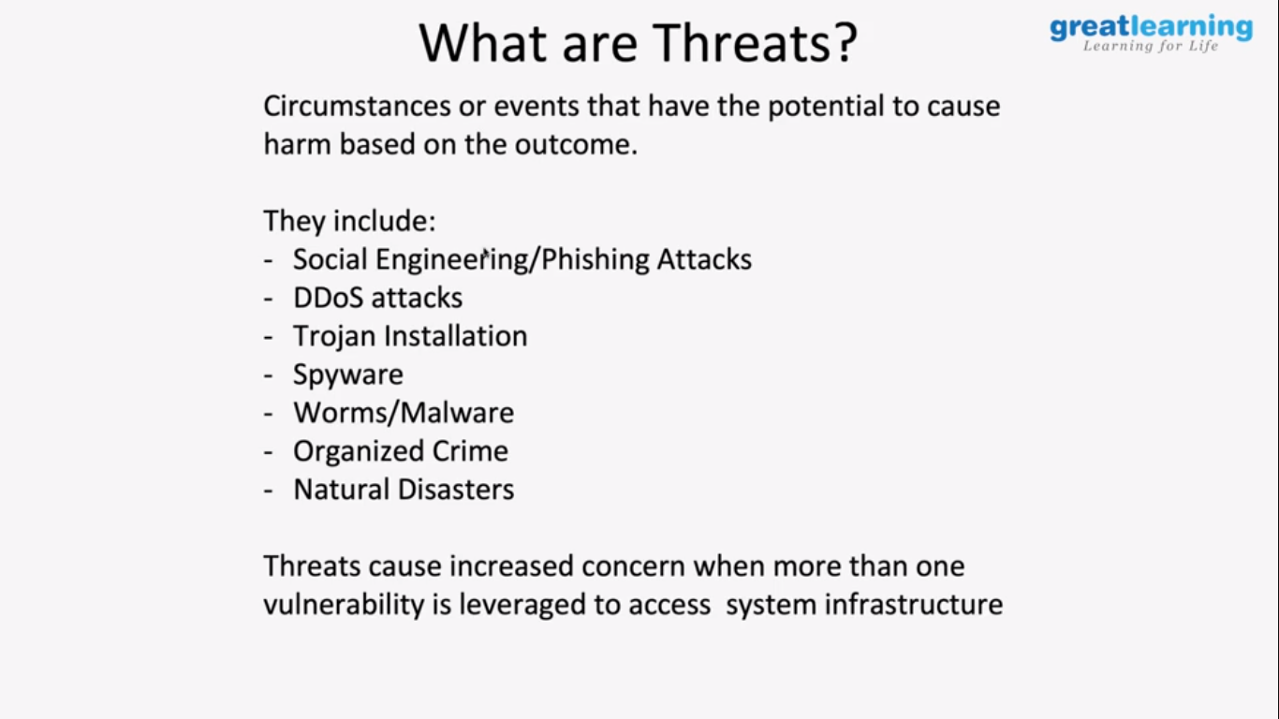 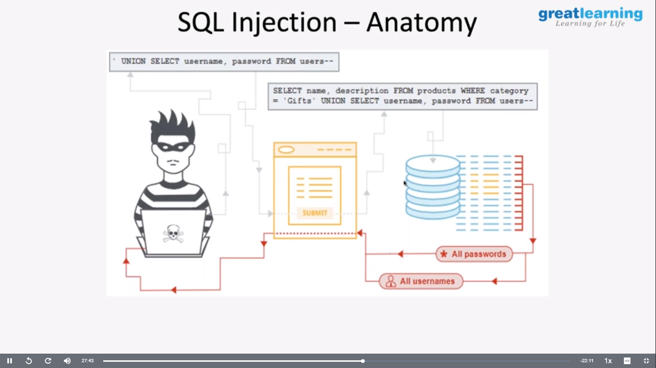

**Online Coding Summary: No problem statements are given.**

**Thank You.**